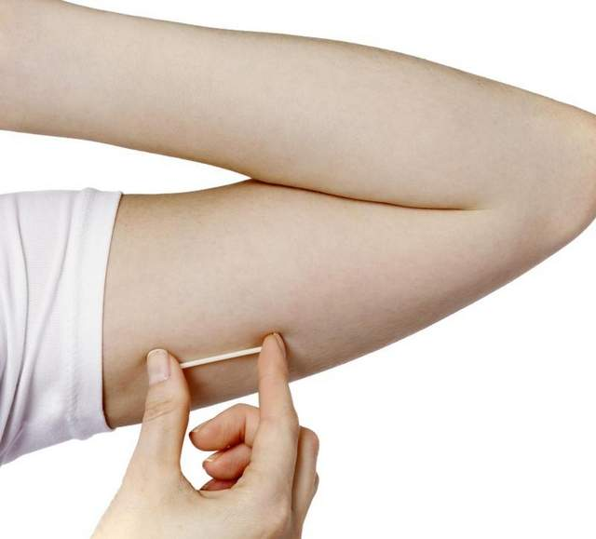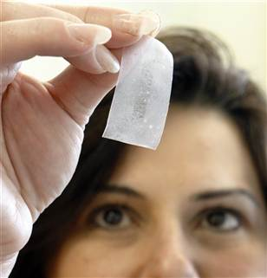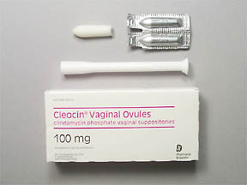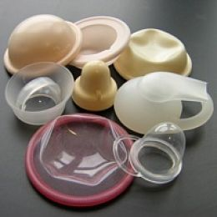

# Implants

# Vaginal Suppository/Tablets

# Barrier Methods

# Vaginal Ring

# Vaginal Film

# Injectables

# Oral Tablets

# Vaginal Gel

#### HIV Prevention – Potential Product Formulations



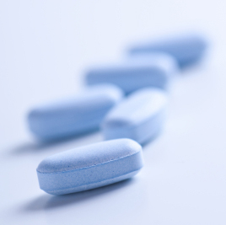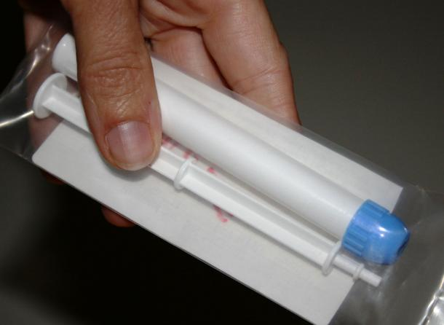

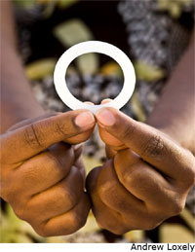

**Key Attributes of Potential Product Formulations**

Vaginal Gel: vaginally administered using an applicator, inserted daily or pericoitally

Oral Tablets: orally administered, used daily

Injectables: injected using a needle, administered once every two-three months

Vaginal Film: vaginally administered using fingers, inserted daily or pericoitally

Vaginal Ring: vaginally administered using fingers, replaced once a month or less frequently (once every three month)

Barrier Methods (Cervical Barriers): vaginally inserted using fingers, used coitally but may be used continuously if removed, cleaned and reinserted daily

Vaginal Suppository/Tablets: vaginally administered using finger or an applicator, inserted daily or pericoitally

Implants: flexible plastic rods placed under the skin of the upper arm; for contraception, implants are inserted every 3-5 years